BUTTON PRAYER

Give everyone a button.

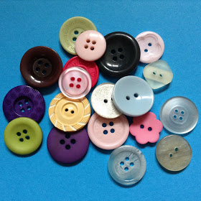

Feel the hardness of the button and think about people who are going through hard times. Ask God to help them.

Buttons are used to fasten clothes together. Ask God to bring together people who have fallen out and moved apart from each other. Pray that He will bring peace.

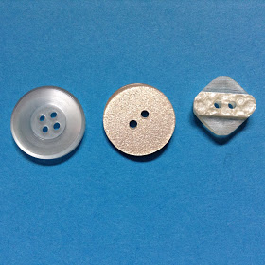

Look at your button and see how many holes it has. Think of that number of things you would like to say thank you to God for and say Thank you prayers.

Look at the color of the button and say thank you to God for something that is that color

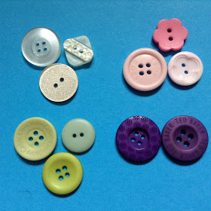

Find someone who has the same color button as you. You might want to make a small group of people with the same color. Say thank you to God for families. Ask God to bless them and help them to live together and to love each other.

Find someone who has a different button as you- it could be different in shape, size or color. Thank God for making everyone different and giving us all different gifts. Pray for the person you have found. Ask Them what they would like God to help them with.

http://flamecreativekids.blogspot.com/2017/07/button-prayers.html?m=1

